## Chapter 1.4 Review of Database Model and Language

***Content:***

In this chapter, do some simple review of SQL and Relational Model.

### Chapter 1.4.1 Review of Relational Model

***Definition:***

1. Relation is the collection of tuple, while tuple is the list of value.
2. All tuples in Relation has the same number of fields, while fields in different tuples has the same type.
3. Show tuple of one Relation is to show each column and row of the Relation.
4. The head of column is called attribute, it represents the meaning of each field.
5. The name of Relation, the name of Attribute and the type of property are all called as the Model of Relation.

***Example:***

The Relation Movie, it may contains the tuples below:

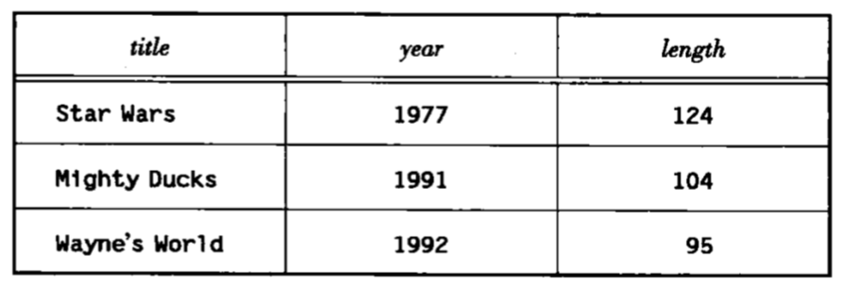

*The Model of Relation is:*

Movie(title, year, length)

1. The name of Relation is ‘Movie’, the name of Attribute are ‘title’, ‘year’ and ‘length’, assume that their type are string, integer and integer.
2. Each line of from the table is one tuple. The first line means that the movie Star Wars is produced in 1977 and the length of the movie is 124 minutes.

***Conclusion:***

Database Model is the collection of Relation Model. The below is the normally used Relation:

Movie(title, year, length, studioName)

MovieStar(name, address, gender, birthdate)

StarsIn(title, year, starName)

Studio(name, address)

### Chapter 1.4.2 Review SQL